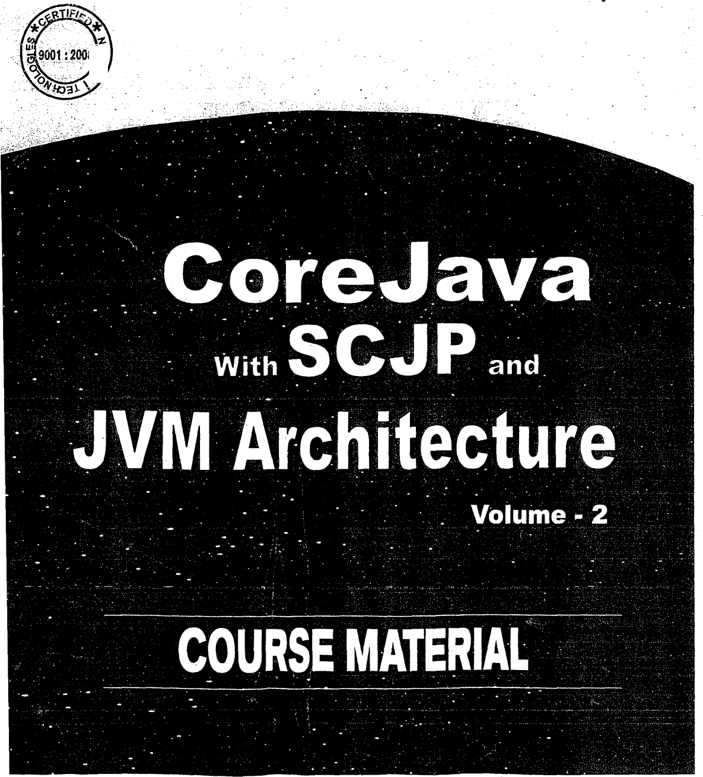

_ TM



Opp. Satya m Theatre,

## Ameerpet, Hyderabad - 500 01b.

*technologies*

## E-maii: info@ nareshit.corn ‹*ww.n ai-eshit.C0ln

Ph:23746666, 23734842 Cd: 9000994 01, 9000994008

# IST? 9001 200g Cer ti fi ed C ompany



Index . ” ” “ . ” "

Volume-1:lavaLanguageandOOPS Chapter#01: )ntroducGdnio1ava&OOPS Chapter #02: Commenti, Identifiers, Keywords Chapter #03: Working with EditPlus Software Chapter #04: DataTypes & Literals

Chapter #05: Wrapper Classes with Autoboxing & unboxing Chapter #06: Exception Handling

Chapter #07: Packages

Chapter #08: Accessibility Modifiers

Chapter #09: Methods and Types of methods Chapter #10: *Variables and Types of Variables Chapter #1”1: JVM Architecture

.Chapter #12: Static Members & their control flow. Chapter #13: Non-Static Members & their control flew Chapter #14: Final Variables and their rules

Chapter #15: Classes and Types of classes Chapter #16: inner classes

Chapter #17: Gesign Patterns

Chapter #18: OOPS Fundamentals and Principles Chapter #19: Types of objects & Garbage Collection Chapter #20: Arrays and *Var-arg* types

Chapter #21: Working with jar Chapter #22: Operators

Chapter #23: Control Statements

u

Volume -2: Java API and Project Chapter #24: API & API Documentation

Chapter #25: Fundamental Classes — Object, Class

Chapter #w6: Multithreading with JVM Architecture Chapter #27: String Handling

Chapter #28: IO Streams (File IO)

Chapter #29: Networking (Socket Programming) Chapter #30: Collections and Generics

Chapter #31: Regular Expressions Chapter #32: Reflection API Chapter #33: Annotations

Chapter #34: AWT, Swings, Applet

Chapter tt35: FoFiTiatting text and date (jaw.text package)

# Thank you for using [www.freepdfconvert.com](http://www.freepdfconvert.com/) service!

Only two pages are converted. Please Sign Up to convert all pages. <https://www.freepdfconvert.com/membership>